**create database oit;**

**use oit;**

**create table oit(eno int primary key,ename varchar(20),designation varchar(20),salary float,date_of_joining varchar(20);**

**select * from oit;**

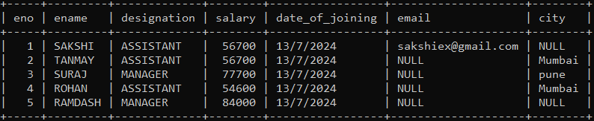

* **LIKE OPERATER**

**1).DISPLAY NAME OF OIT WHOSE NAME START WITH A & ENDS WITH A AND DESINATION IS SR.MANAGER AND HE/SHE BELONG TO PUNE OR MUMBAI OR NAGPUR.**

**🡪**



**alter table oit add column phone_no int;**

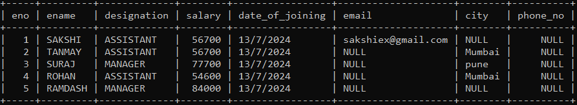

**2)**  **Display the details of the employee whose email contains . character and salary between 10000 to 20000 or employee id is either 1,12,31,49**

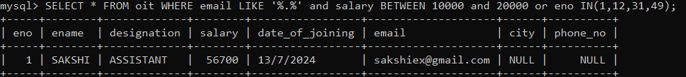

**3)DISPLAY NAME OF OIT DESIGNATION AND PHONE OF OIT WHOSE NAME HAVING THRID CHARACTER IS A AND END WITH T AND ALSO EMAIL HAVING ‘@’ CHARACTER AND ‘.’ CHARATER AND PHONE NO GREATER OR EQUAL TO ‘1234567890’.**



* **ORDER BY**

**1) DISPLAY DETAILS OF OIT NAME ITS DESCENDING ORDER WHOSE NAME CANTAINS ONLY 5 CHARATER.**

**🡪 SELECT * FROM oit WHERE ename LIKE'_ _ _ _ _' ORDER BY ename desc;**

